SPRINT 2

|  |  |
| --- | --- |
| **DATE** | 05 NOVEMBER 2022 |
| **TEAM ID** | PNT2022TMID29836 |
| **PROJECT NAME** | Customer Care Registry |

IBM WATSON ASSISTANT

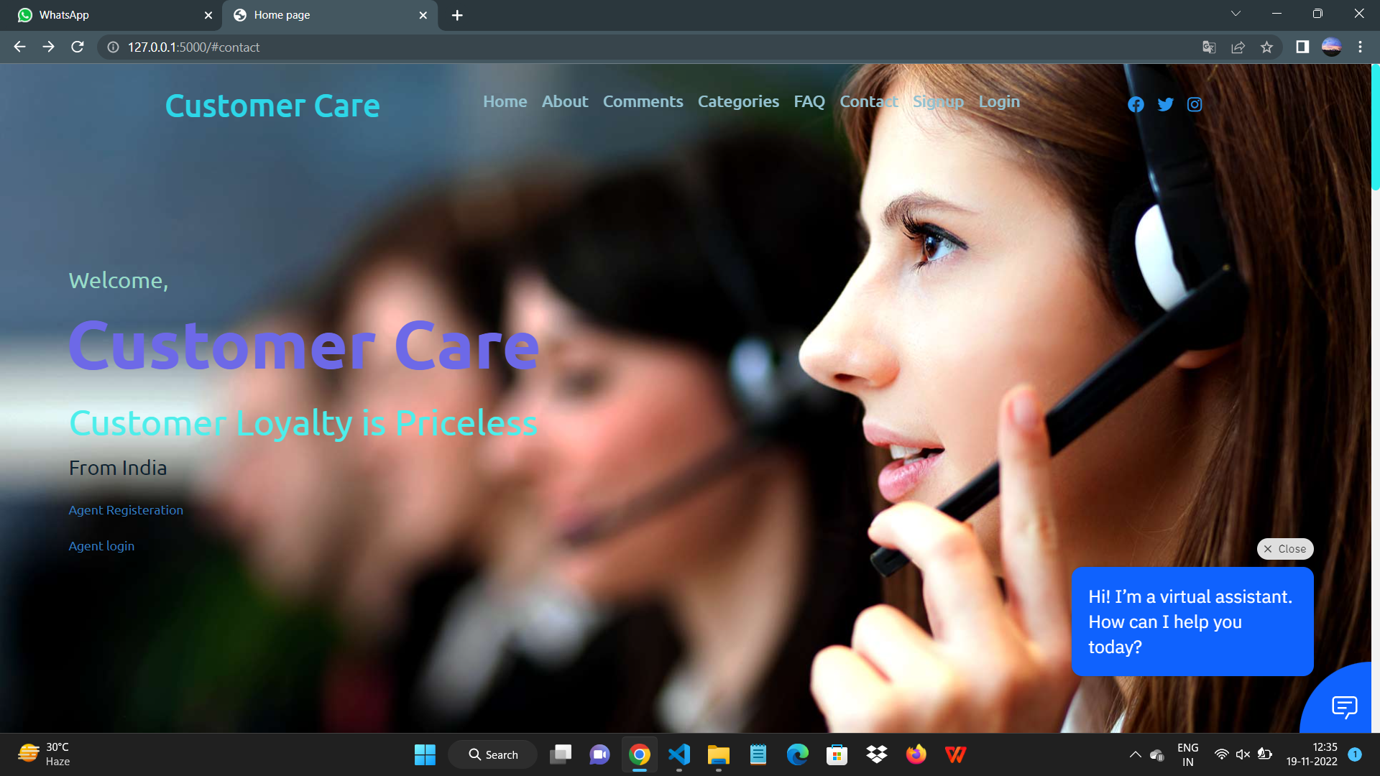

IBM WATSON ASSISTANT CODE :

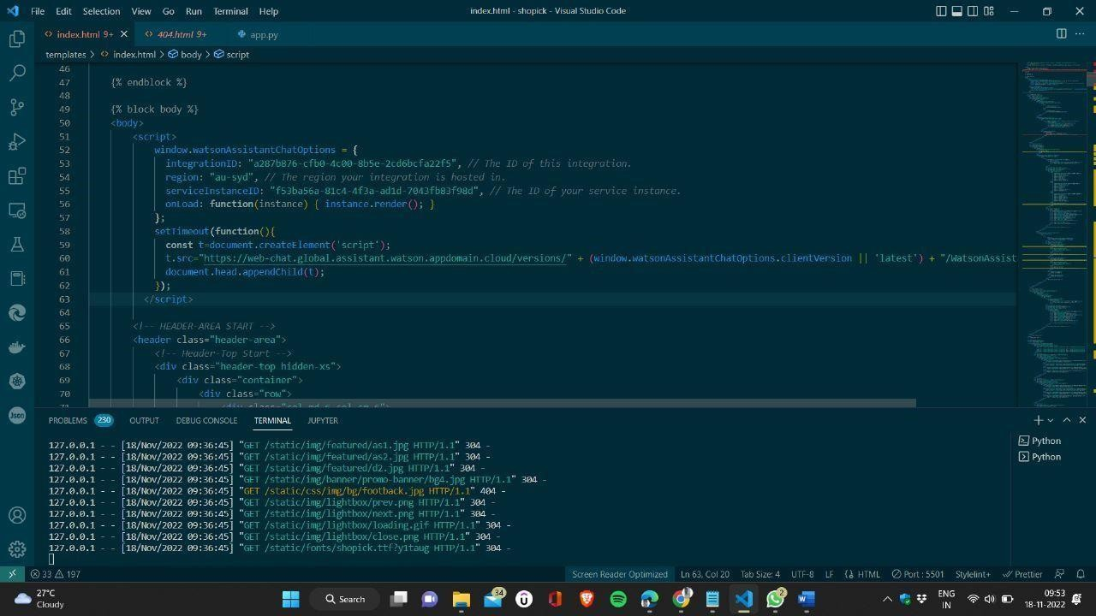

**IBM DB2 (DATA BASE):**

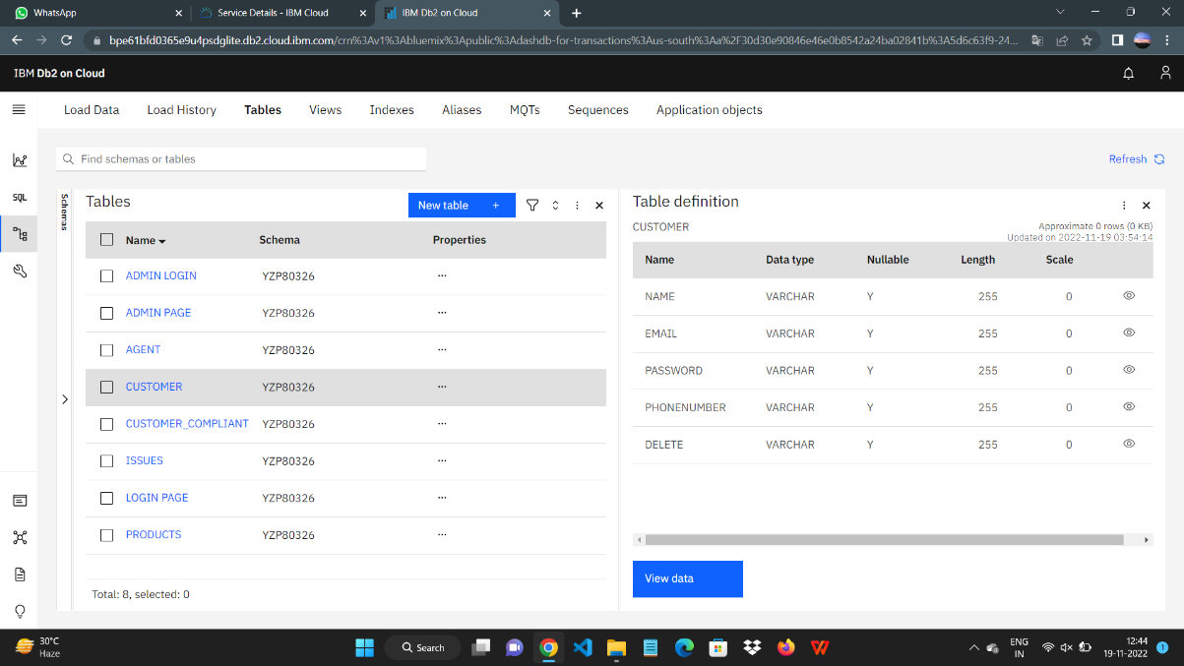

DATA BASE CONNECTIVITY

